Kingdom of Saudi Arabia  Ministry of Education  Hafr Al Baten Educational Directorate for boys  Al –Ajial International Schools |  |  |  |      |  |  | Date: /10/2026  Subject: Computer  Class.: Grade 2  Time:……….
……………… |  | Seat Number |  | ……………………………………………... |  |  |  | Student’s Name
First Semester Examination 2025/2026
Sign. | Consultative Name |  | Sign. |  | Corrector’s Name | Marks in letters |  |  | Marks  in numbers
 |  |  |  |  | Ahmed Mahmood
 |  |  |  |  |  |  |  |  | 40

QUESTION A: Fill in the blank with the correct file types.
Audio Document Image Video

File | File Type | File | File Type
 | ______________  ______________ |  | ______________  ______________
 | ______________  ______________ |  | ______________  ______________

QUESTION B: Fill in the blank with the words in the box below.
Image Right Paste Music Movies and TV

1. In flower.jpg, ‘.jpg’ is an _____________
2. We use _________ click to open the option menu.
3. We cannot use the _________ command without copy or cut.
4. .mp4 is a type of _________ file.
5. __________ is used to watch a video on a computer.

QUESTION C: State whether the below statements are True or False.
1. We have two buttons on a mouse, left and right.
(a) True (b) False
2. The wheel on the mouse is called Scroll wheel.
(a) True (b) False
3. We use cut and paste to move a files.
(a) True (b) False
4. We use paste command to create a duplicate files.
(a) True (b) False
5. We use right click to open the home menu.
(a) True (b) False

QUESTION D: Match the following

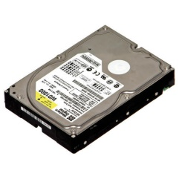 | UPS
 | HEADPHONE
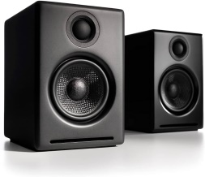 | HARD DISK
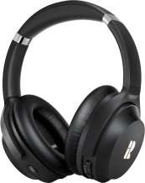 | PROCESSOR
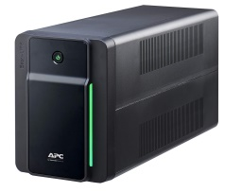 | SPEAKER

